EXP NO: 05 DATE:

RECOGNIZE A VALID VARIABLE WHICH STARTS WITH A LETTER

FOLLOWED BY ANY NUMBER OF LETTERS OR DIGITS USING LEX AND YACC

Problem Statement:

Recognizes a valid variable name. The variable name must start with a letter (either uppercase or lowercase) and can be followed by any number of letters or digits. The program should validate whether a given string adheres to this naming convention.

AIM:

To develop a LEX and YACC program that recognizes a valid variable name in C programming, which:

* Starts with a letter (a-z or A-Z)
* Followed by any number of letters or digits (a-z, A-Z, 0-9, _)
* Does not allow invalid characters (e.g., 123abc, @var, x!y)

ALGORITHM:

Step 1: A Yacc source program has three parts as follows: Declarations %% translation rules

%% supporting C routines

Step 2: Declarations Section: This section contains entries that:

Include standard I/O header file.

Define global variables.

Define the list rule as the place to start processing.

Define the tokens used by the parser.

Step 3: Rules Section: The rules section defines the rules that parse the input stream. Each rule of a grammar production and the associated semantic action.

Step 4: Programs Section: The programs section contains the following subroutines. Because these subroutines are included in this file, it is not necessary to use the yacc library when processing this file.

Main- The required main program that calls the yyparse subroutine to start the program. yyerror(s) -This error-handling subroutine only prints a syntax error message.

yywrap -The wrap-up subroutine that returns a value of 1 when the end of input occurs. The calc.lex file contains include statements for standard input and output, as programmer file

information if we use the -d flag with the yacc command. The y.tab.h file contains definitions for

the tokens that the parser program uses.

Step 5:calc.lex contains the rules to generate these tokens from the input stream.

PROGRAM:

Lex.l

%{

#include "yac.tab.h"

#include <stdio.h>

int yywrap(void) { return 1;

}

%}

%%

[a-zA-Z_][a-zA-Z0-9_]* { return IDENTIFIER; }

\n { return 0; }

. { return yytext[0]; }

%%

Yac.y

%{

#include <stdio.h>

#include <stdlib.h>

extern char *yytext; int yylex(); int yyerror(char *msg);

%}

%token IDENTIFIER

%%

variable: IDENTIFIER { printf("Valid variable name: %s\n", yytext); }

;

%%

int main() { printf("Enter a variable name:\n");

yyparse(); return 0;

}

int yyerror(char *msg) { printf("Error: %s\n", msg);

return 0; }

OUTPUT :

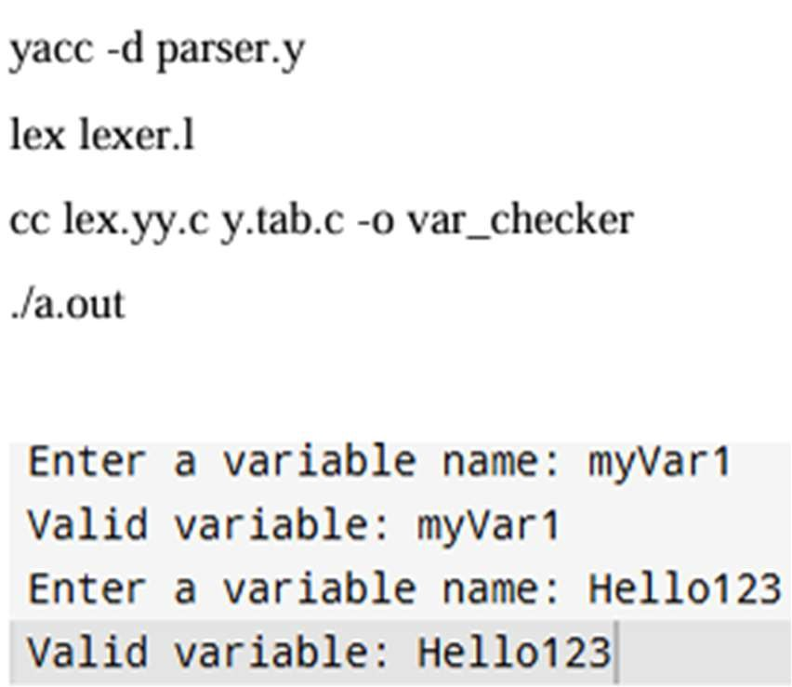

|  |  |
| --- | --- |
| Implementation |  |
| Output/Signature |  |

RESULT:

Thus the above program reads an input string, checks whether it follows the rules for a valid variable name, and produces the following output.